SHOPPING LIST APP

Furba Sherpa – 101085699
Group - G 4
CRN - 50492

- A shopping list application that includes a tax calculator, organizes items into multiple product categories (such as food, medications, and cleaning supplies), and allows users to create and manage their own custom categories.

- The application will store data such as product names and product categories.

- Data storage of choice for this application will be core data for its scalability, safety and development efficiency. Core data also naturally supports Relationships which will be needed for the categories feature for this application.

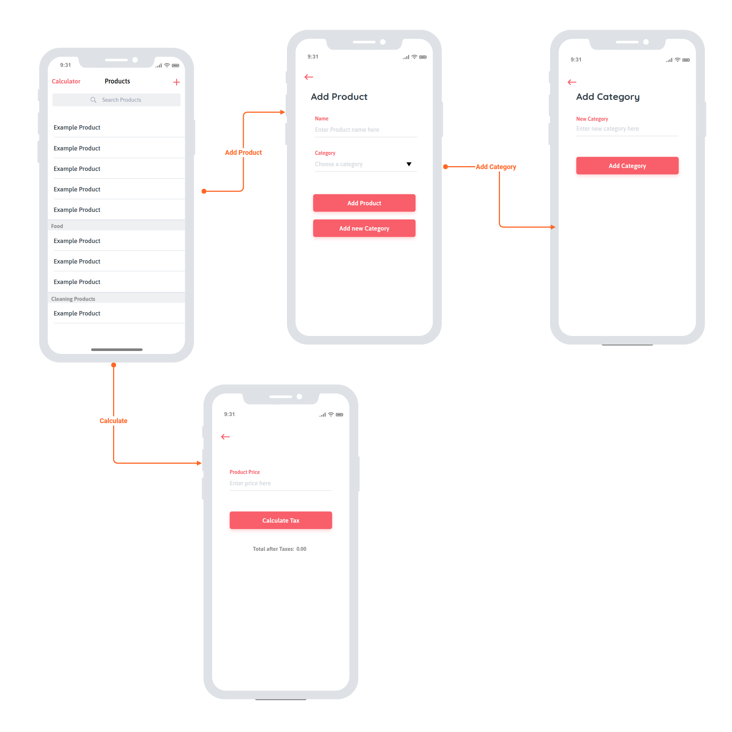
- The mock-up shown above shows the main screen of the application first which shows a list of the products grouped by category such as “Food” and “Cleaning Products”.

- Next is the Add product/Add new category page will take a text input and the user is able to choose a specific category from the drop down menu or use the “Add new category” button which will take the user to another screen where they can enter a new category of their own which will then be available to select in the “Add Product” screen.

- The Fourth screen is the tax calculator screen where the user is able to enter the price for any product and get the total cost of the product after taxes have been included once the “Calculate Tax” button is pressed.

